# Bearing calculation description

## Flowchart

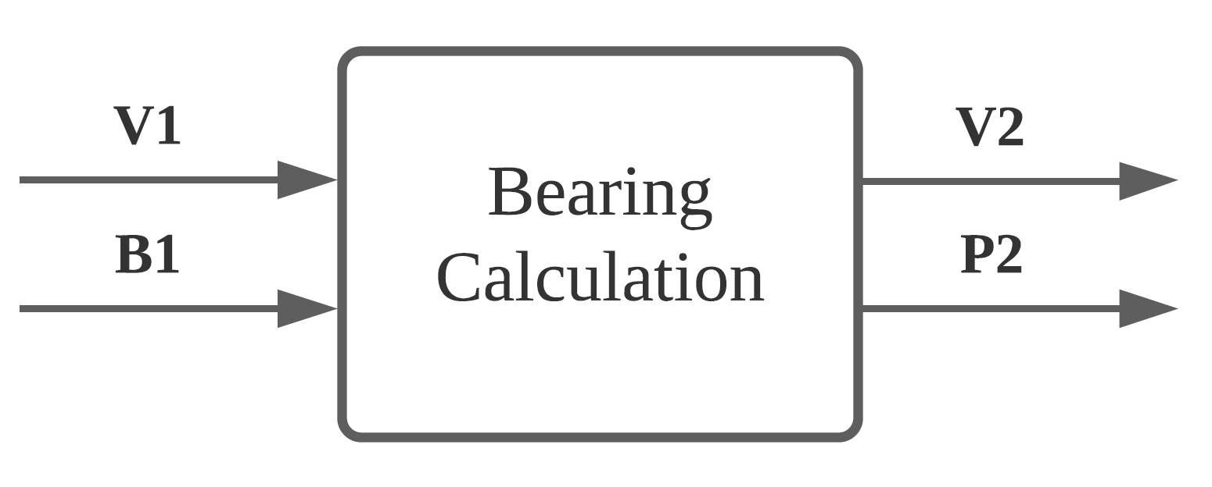

Figure 1 Bearing component flowchart

## Unique identifiers

|  |  |
| --- | --- |
| Unique ID | Long Name |
| V1 | Input from user-interface sub-system |
| B1 | Input from gearing component |
| V2 | Output to user-interface sub-system |
| P2 | Output to propellor component |

## Table of limits

|  |  |  |  |  |
| --- | --- | --- | --- | --- |
| Interaction | Symbol | Min. | Max. | Unit |
| -> V1 | | | | |
| *Input from user-interface sub-system* | | | | |
| Friction coefficient bearing | µ | 0,0015 | 0,0050 |  |
| Friction coefficient seal | µ | 0,0015 | 0,0050 |  |
| Radius shaft | r | 0 | 0,05 | M |
| Load | $$F_{load}$$ | 0 | 1000 | N |
| -> B1 | | | | |
| *Input from gearing component* | | | | |
| Gearing power output | $$P_{Gear-out}$$ | 0 | 8400 | W |
| Gearing torque output | $$T_{Gear-out}$$ | 0 | 3500 | Nm |
| Gearing rotation speed output | $$ω_{Gear-out}$$ | 0 | 2200 | rpm |
| <- V2 | | | | |
| *Output to user-interface sub-system* | | | | |
| Power loss | $$P_{Bearing-loss}$$ | 0 | 8400 | W |
| <- P2 | | | | |
| *Output to propellor component* | | | | |
| Bearing power output | $$P_{Bearing-out}$$ | 0 | 8400 | W |
| Bearing torque output | $$T_{Bearing-out}$$ | 0 | 3500 | Nm |

|  |  |
| --- | --- |
| Bearing Type | Coefficient of friction µ |
| Deep Groove Ball Bearing | 0,0015 |
| Angular Contact Bearing | 0,0020 |
| Cylindrical Roller Bearing, Cage | 0,0010 |
| Cylindrical Roller Bearing, Full Comp. | 0,0020 |
| Tapered Roller Bearing | 0,0020 |
| Spherical Roller Bearing | 0,0020 |
| Ball Thrust Bearing | 0,0015 |
| Cylindrical Roller Thrust Bearing | 0,0050 |
| Tapered Roller Thrust Brg. Cage | 0,0020 |
| Tapered Roller Thrust Brg. Full Comp | 0,0050 |